Kafka Integration with Signoz
Pre-Requisite
Kafka Standalone VM – 1 broker

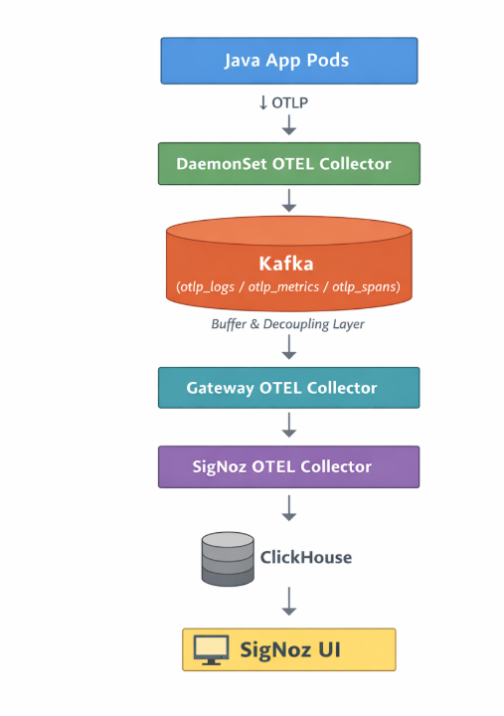

PART – 1 [In Kafka VM]
In Kafka VM, create topics:
# Create traces topic - 1 partition, no replication (single broker)
/opt/kafka/bin/kafka-topics.sh --create \ --bootstrap-server localhost:9092 \ --topic otlp_spans \ --partitions 3 \ --replication-factor 1
# Create metrics topic
/opt/kafka/bin/kafka-topics.sh --create \ --bootstrap-server localhost:9092 \ --topic otlp_metrics \ --partitions 3 \ --replication-factor 1
# Create logs topic
/opt/kafka/bin/kafka-topics.sh --create \ --bootstrap-server localhost:9092 \ --topic otlp_logs \ --partitions 3 \ --replication-factor 1
# Verify topics
/opt/kafka/bin/kafka-topics.sh --list --bootstrap-server localhost:9092
# Describe topics to verify
/opt/kafka/bin/kafka-topics.sh --describe --bootstrap-server localhost:9092

Add inbound rule: (IF NEEDED)

PART-2: SIGNOZ COLLECTOR VM
STEP-1
sudo systemctl stop signoz-otel-collector.service
STEP-2: Test Connectivity to Kafka
nc -zv 172.31.33.133 19092
STEP-3: Deploy Gateway Collector
# Create directories
sudo mkdir -p /opt/otel-gateway/bin
sudo mkdir -p /opt/otel-gateway/conf

# Download standard OTel Collector
cd /tmp
wget https://github.com/open-telemetry/opentelemetry-collector-releases/releases/download/v0.139.0/otelcol-contrib_0.139.0_linux_amd64.tar.gz
tar -xzf otelcol-contrib_0.139.0_linux_amd64.tar.gz

# Move binary
sudo mv otelcol-contrib /opt/otel-gateway/bin/

# Create user
sudo useradd --system --home /opt/otel-gateway --no-create-home --user-group --shell /sbin/nologin otelgateway
# Set permissions
sudo chown -R otelgateway:otelgateway /opt/otel-gateway
sudo chmod +x /opt/otel-gateway/bin/otelcol-contrib

STEP-4: Create Gateway Config (Single Broker)
NOTE: The issue is that service.telemetry.metrics.address is not valid in this version of OTel collector. So removing this part.
sudo tee /opt/otel-gateway/conf/config.yaml > /dev/null <<'EOF'
receivers:
kafka/traces:
brokers:
- 172.31.33.133:19092
topic: otlp_spans
group_id: otel-gateway-traces
encoding: otlp_proto
initial_offset: earliest

kafka/metrics:
brokers:
- 172.31.33.133:19092
topic: otlp_metrics
group_id: otel-gateway-metrics
encoding: otlp_proto
initial_offset: earliest

kafka/logs:
brokers:
- 172.31.33.133:19092
topic: otlp_logs
group_id: otel-gateway-logs
encoding: otlp_proto
initial_offset: earliest

processors:
batch:
send_batch_size: 2048
timeout: 10s
memory_limiter:
check_interval: 1s
limit_mib: 2048
spike_limit_mib: 512

exporters:
otlp/signoz:
endpoint: localhost:4317
tls:
insecure: true
retry_on_failure:
enabled: true
initial_interval: 5s
max_interval: 60s
max_elapsed_time: 300s
sending_queue:
enabled: true
num_consumers: 10
queue_size: 5000

extensions:
health_check:
endpoint: 0.0.0.0:13134

service:
extensions: [health_check]
pipelines:
traces:
receivers: [kafka/traces]
processors: [memory_limiter, batch]
exporters: [otlp/signoz]
metrics:
receivers: [kafka/metrics]
processors: [memory_limiter, batch]
exporters: [otlp/signoz]
logs:
receivers: [kafka/logs]
processors: [memory_limiter, batch]
exporters: [otlp/signoz]
EOF
sudo chown otelgateway:otelgateway /opt/otel-gateway/conf/config.yaml

Step 5: Create Gateway Systemd Service
NOTE: Now update the systemd service to pass the metrics port as an environment variable
sudo tee /etc/systemd/system/otel-gateway.service > /dev/null <<'EOF'
[Unit]
Description=OpenTelemetry Gateway Collector
Documentation=https://opentelemetry.io/docs/
After=network.target

[Service]
User=otelgateway
Group=otelgateway
Type=simple
Restart=on-failure
RestartSec=10
WorkingDirectory=/opt/otel-gateway
Environment="OTEL_METRICS_EXPORTER=none"
ExecStart=/opt/otel-gateway/bin/otelcol-contrib --config=/opt/otel-gateway/conf/config.yaml --set=service.telemetry.metrics.level=none
StandardOutput=journal
StandardError=journal

[Install]
WantedBy=multi-user.target
EOF

STEP-6: Start the services
sudo systemctl daemon-reload

# Start Gateway first (no conflict now since metrics disabled)
sudo systemctl start otel-gateway.service

# Check status immediately
sudo systemctl status otel-gateway.service

# Check logs
sudo journalctl -u otel-gateway.service -n 20 --no-pager

PART-3: K8s VM
# On K8s VM
cat > collector-daemonset.yaml <<'EOF'
apiVersion: opentelemetry.io/v1beta1
kind: OpenTelemetryCollector
metadata:
name: signoz-collector-daemonset
namespace: opentelemetry-operator-system
spec:
mode: daemonset
hostNetwork: true
image: docker.io/otel/opentelemetry-collector-contrib:0.139.0
env:
- name: K8S_NODE_NAME
valueFrom:
fieldRef:
fieldPath: spec.nodeName
- name: K8S_HOST_IP
valueFrom:
fieldRef:
fieldPath: status.hostIP
- name: K8S_POD_IP
valueFrom:
fieldRef:
apiVersion: v1
fieldPath: status.podIP
- name: K8S_POD_NAME
valueFrom:
fieldRef:
fieldPath: metadata.name
- name: K8S_POD_UID
valueFrom:
fieldRef:
fieldPath: metadata.uid
- name: K8S_NAMESPACE
valueFrom:
fieldRef:
fieldPath: metadata.namespace
- name: SIGNOZ_COMPONENT
value: otel-daemonset
- name: K8S_CLUSTER_NAME
value: 'my-k3s-cluster'
- name: OTEL_RESOURCE_ATTRIBUTES
value: signoz.component=$(SIGNOZ_COMPONENT),k8s.cluster.name=$(K8S_CLUSTER_NAME)

volumes:
- name: varlog
hostPath:
path: /var/log
- name: varlibdockercontainers
hostPath:
path: /var/lib/docker/containers
- name: hostfs
hostPath:
path: /

volumeMounts:
- name: varlog
mountPath: /var/log
readOnly: true
- name: varlibdockercontainers
mountPath: /var/lib/docker/containers
readOnly: true
- name: hostfs
mountPath: /hostfs
readOnly: true
mountPropagation: HostToContainer

config:
exporters:
kafka/traces:
brokers:
- 172.31.33.133:19092
topic: otlp_spans
encoding: otlp_proto
producer:
max_message_bytes: 10485760
compression: gzip
required_acks: 1

kafka/metrics:
brokers:
- 172.31.33.133:19092
topic: otlp_metrics
encoding: otlp_proto
producer:
max_message_bytes: 10485760
compression: gzip
required_acks: 1

kafka/logs:
brokers:
- 172.31.33.133:19092
topic: otlp_logs
encoding: otlp_proto
producer:
max_message_bytes: 10485760
compression: gzip
required_acks: 1

receivers:
otlp:
protocols:
grpc:
endpoint: 0.0.0.0:4317
http:
endpoint: 0.0.0.0:4318

filelog/k8s:
exclude:
- /var/log/pods/opentelemetry-operator-system_*/*/*.log
- /var/log/pods/kube-system_*/*/*.log
include:
- /var/log/pods/*/*/*.log
include_file_name: false
include_file_path: true
operators:
- id: container-parser
type: container
start_at: end

hostmetrics:
collection_interval: 30s
root_path: /hostfs
scrapers:
cpu: {}
memory: {}
disk: {}
filesystem: {}
load: {}
network: {}

kubeletstats:
auth_type: serviceAccount
collection_interval: 30s
endpoint: ${env:K8S_HOST_IP}:10250
insecure_skip_verify: true
metric_groups: [container, pod, node, volume]

processors:
batch:
send_batch_size: 10000
timeout: 200ms
k8sattributes:
extract:
metadata:
- k8s.namespace.name
- k8s.deployment.name
- k8s.statefulset.name
- k8s.daemonset.name
- k8s.cronjob.name
- k8s.job.name
- k8s.node.name
- k8s.node.uid
- k8s.pod.name
- k8s.pod.uid
- k8s.pod.start_time
filter:
node_from_env_var: K8S_NODE_NAME
passthrough: false
pod_association:
- sources:
- from: resource_attribute
name: k8s.pod.ip
- sources:
- from: resource_attribute
name: k8s.pod.uid
- sources:
- from: connection
resourcedetection:
detectors: [k8snode, env, system]
k8snode:
auth_type: serviceAccount
node_from_env_var: K8S_NODE_NAME
override: false
timeout: 2s

service:
pipelines:
traces:
receivers: [otlp]
processors: [resourcedetection, k8sattributes, batch]
exporters: [kafka/traces]

metrics:
receivers: [otlp, hostmetrics, kubeletstats]
processors: [resourcedetection, k8sattributes, batch]
exporters: [kafka/metrics]

logs:
receivers: [otlp, filelog/k8s]
processors: [resourcedetection, k8sattributes, batch]
exporters: [kafka/logs]
EOF

# Apply
kubectl apply -f collector-daemonset.yaml

# Wait for pod to restart
kubectl rollout status daemonset/signoz-collector-daemonset-collector \
-n opentelemetry-operator-system

# Check logs
kubectl logs -n opentelemetry-operator-system \
daemonset/signoz-collector-daemonset-collector --tail=30

IMPLEMENTATION SCREENSHOTS
- Kafka topics
/opt/kafka/bin/kafka-topics.sh --bootstrap-server localhost:9092 --list
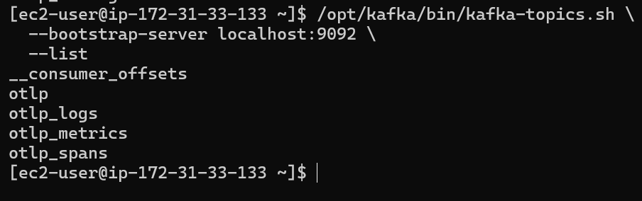
- Topic describe
/opt/kafka/bin/kafka-topics.sh --bootstrap-server localhost:9092 --describe --topic otlp_metrics
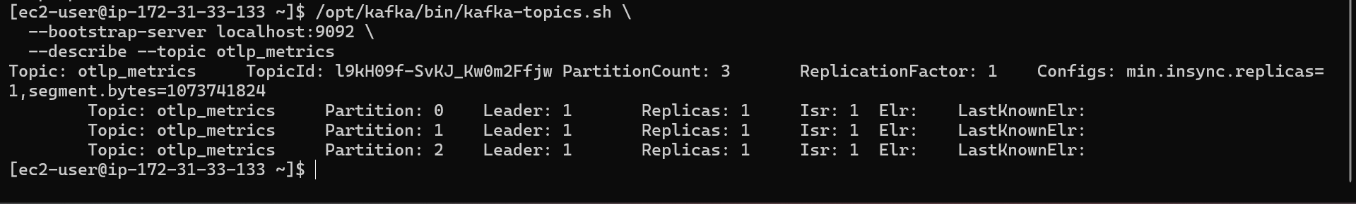
- Kafka is receiving metrics
/opt/kafka/bin/kafka-console-consumer.sh \
--bootstrap-server localhost:9092 \
--topic otlp_metrics \
--from-beginning \
--timeout-ms 5000

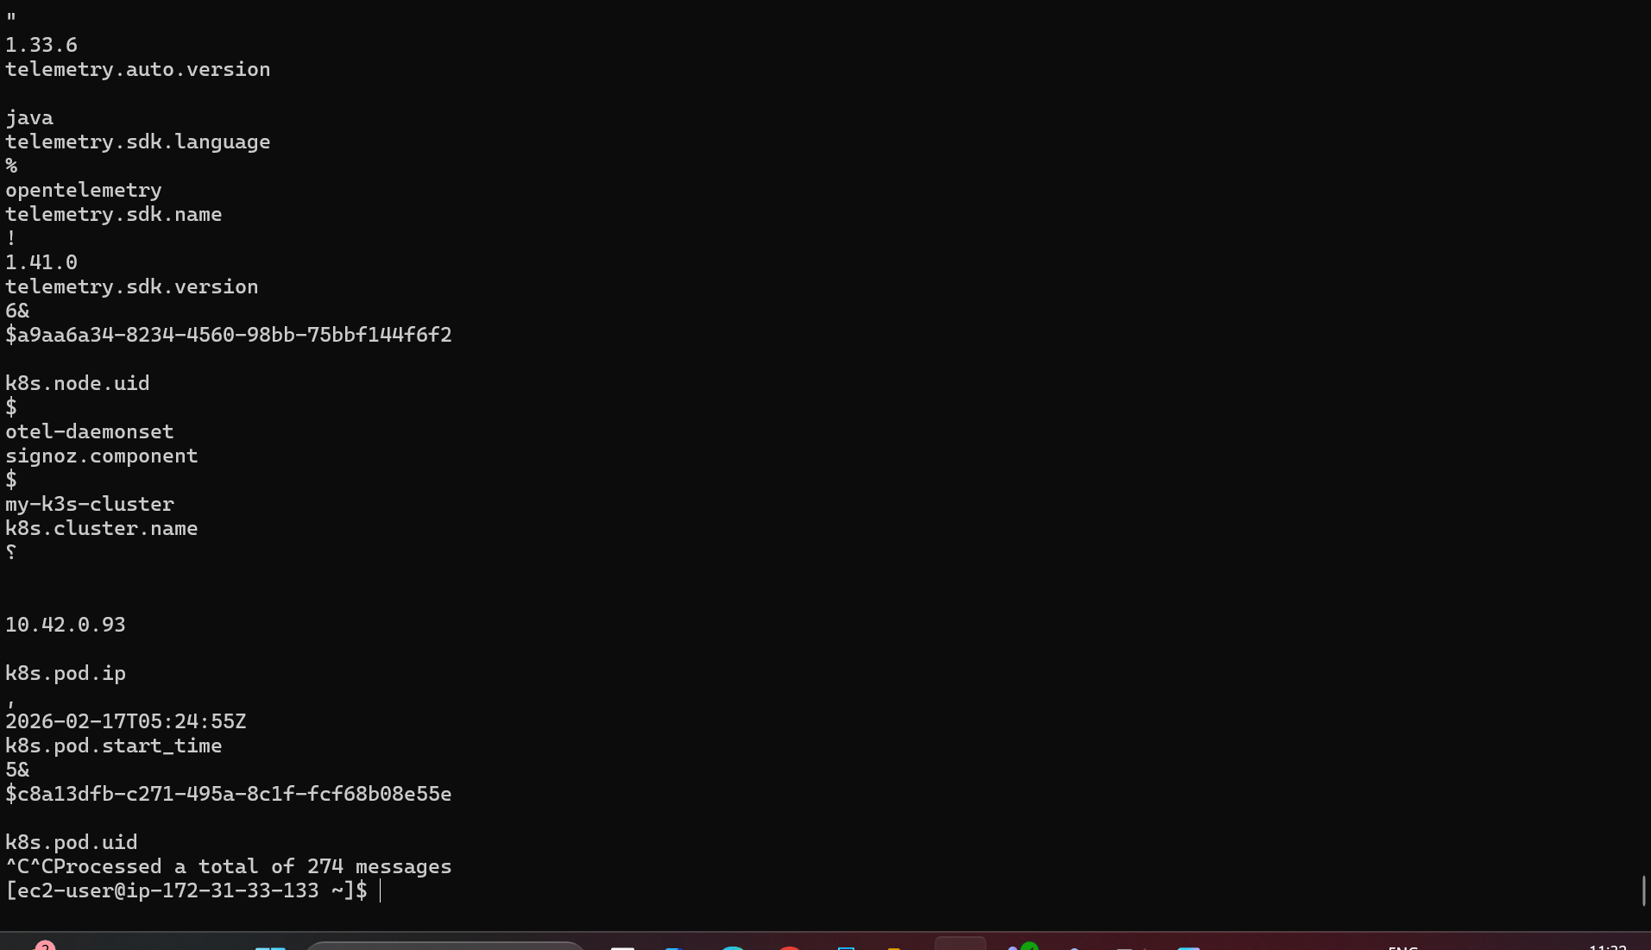
- Gateway collector consuming metrics
/opt/kafka/bin/kafka-consumer-groups.sh \
--bootstrap-server localhost:9092 \
--describe --group otel-gateway-metrics
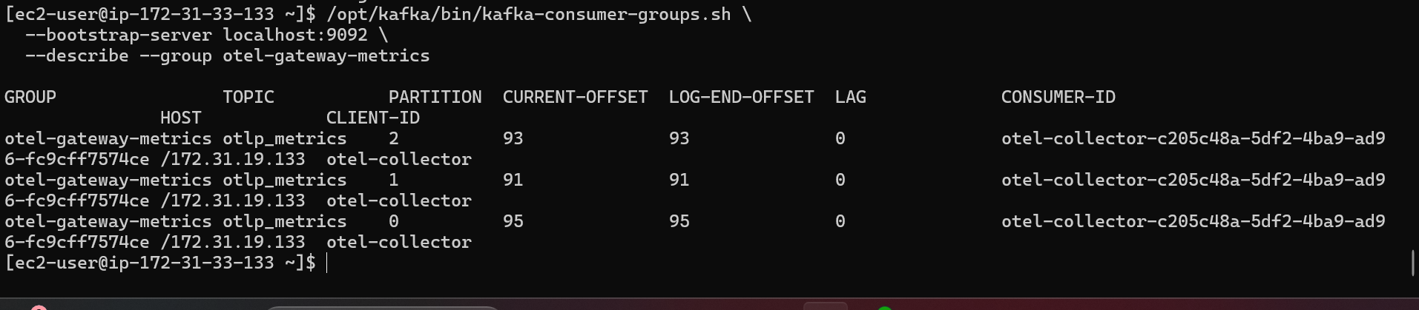

- SigNoz Metrics UI
